Ex. No.: 9
Date:

Query with Joins – Equi Join, Inner Join, Outer Join

AIM: To perform JOIN using Equi Join, Inner Join, Outer Join on the given relation.

DESCRIPTION:
JOIN
A MySQL join is a method of linking data from one or more table based on values of the common column between tables.

MySQL supports the following types of joins:
- Cross join
- Inner join
- Left join
- Right join

CROSS JOIN

The CROSS JOIN makes a Cartesian product of rows from multiple tables. Suppose, you join t1 and t2 tables using the CROSS JOIN, the result set will include the combinations of rows from the t1 table with the rows in the t2 table.

INNER JOIN
To join two tables, the INNER JOIN compares each row in the first table with each row in the second table to find pairs of rows that satisfy the join-predicate. Whenever the join-predicate is satisfied by matching non-NULL values, column values for each matched pair of rows of the two tables are included in the result set.

LEFT JOIN
Unlike an INNER JOIN, a LEFT JOIN returns all rows in the left table including rows that satisfy join-predicate and rows do not. For the rows that do not match the join-predicate, NULLs appear in the columns of the right table in the result set.

RIGHT JOIN

A RIGHT JOIN is similar to the LEFT JOIN except that the treatment of tables is reversed. With a RIGHT JOIN, every row from the right table ( t2) will appear in the result set. For the rows in the right table that do not have the matching rows in the left table ( t1), NULLs appear for columns in the left table ( t1).

SYNTAX:

CROSS JOIN:
SELECTt1.id, t2.id FROMt1CROSS JOIN t2;

INNER JOIN:
SELECTt1.id, t2.id
FROMt1INNER JOINt2 ON t1.pattern = t2.pattern;

LEFT JOIN:
SELECTt1.id, t2.id
FROMt1LEFT JOINt2 ON t1.pattern = t2.pattern
ORDER BY t1.id;

RIGHT JOIN:
SELECTt1.id, t2.id
FROMt1RIGHT JOINt2 ON t1.pattern = t2.pattern

ORDER BYt2.id;

Questions:
1.Display the employee name and department name using INNER JOIN.
2. Display all employees and their department names using LEFT JOIN.
3. Display all departments and their employees using RIGHT JOIN.
4. Display all combinations of employees and departments using CROSS JOIN.
5. Display all combinations of employees and departments using CROSS JOIN.

OUTPUTS:

1)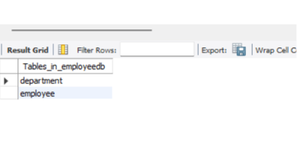

2)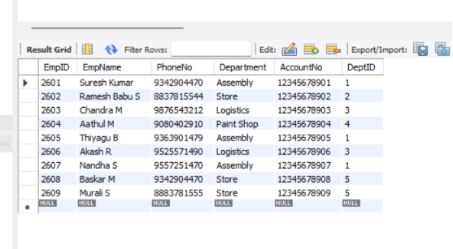

3)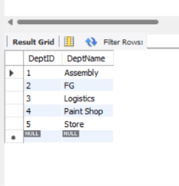

4)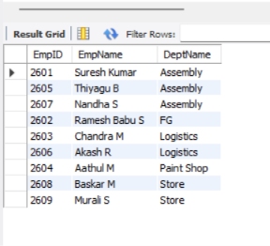

5)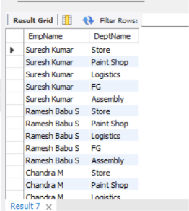

6)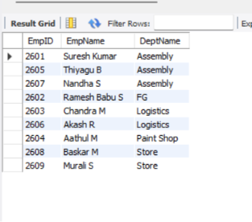

RESULT:

The JOIN operations (Equi Join, Inner Join, Left Join, Right Join, and Cross Join) were successfully performed on the Employee and Department tables, and the required records were displayed.

